An overview of your organisation, its business strategy and structure **(LO1)**

Overviews are quite short

Use some of the information you have found on websites

Will probably use 1 – 2 sources

Your role and key competencies – Identify the key competencies you require for your role and compare these to your apprenticeship standard. Explain the relevance of the apprenticeship standard to your role and organisation **(LO1)**

Think of things I need to do in my role, possibly ask people what I need (a reference)

Describe apprentischip standard (probably use another source) (my job description pretty much)

Explain its relevance to work and my roles

Reflect on an opportunity for workplace improvement – Identify a potential issue or opportunity where you may be sable to contribute to the organisation and act for improvement as part of a future work-based inquiry. Carry out a structured reflection on an event that relates to this area of inquiry by using a reflective model such as: Gibbs (1988), Kolb (1984). **(LO4)**

Use a reflection (if using Gibbs then in the feelings bit do something like ***What did you feel leading up to the event? What did you feel during the event? What did you feel after the event? How do you look back on the situation? What do you think other people felt during event? How do you think others feel about the event now?*)**

Examples of opportunities for workplace improvement (based on previous projects undertaken by Level 5 apprentices):

• Investigating the effectiveness of Scrum as implemented in a specific development team

• Investigating frustrations about negative impacts of increased workload and growing team size

• Investigating potential solutions to the lack of a record of a team's rules and how they work on a regular basis in order to help new team members onboard more successfully

• How to improve effective communication across departments on large scale projects to make sure that work is scheduled correctly and synchronised, with dependencies addressed

• Investigating how to achieve commitment within a team to make accessibility an ongoing priority in the app development process.

Are you talking about the evidence of your abilities/skills/behaviours? Sure.. but it would be better evidence if you could get it in writing from them or summarise what they said and then get them to confirm (e.g., via email) that it is accurate

**Could write about 22.2 hours a year of public engagement (long time with a lot of talking involved)**

**Could write about the short morning meetings every day (breaks day up, not very useful) and what could be done instead (longer meeting every week (end or start))**

* Information to be included on cover sheet: Student Name, Student ID, and Word Count (excluding end references section, appendices, and table of contents)
* Structure your assignment appropriately with sub-headings, an introduction, and conclusion
* Include a reference list.
* File format: Microsoft Word or PDF document

Use Harvard referencing

This assignment type is a reflective report

Apprentisshi[p helps with busnes strategy keeping a steady stream of stem subject using the public money, ongoing pipeline for stem carrers (ensures future research)

Strategic plan people and carreers (objectives)

STFC resourcing department job description

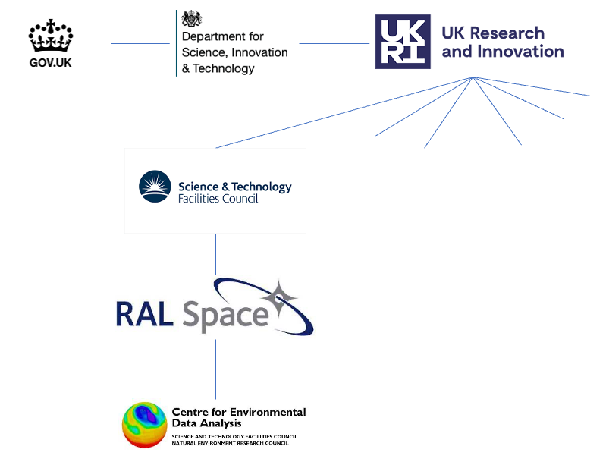

https://www.instituteforapprenticeships.org/apprenticeship-standards/digital-and-technology-solutions-professional-integrated-degree-v1-1

https://www.ukri.org/wp-content/uploads/2022/08/UKRI-190822-CorporatePlan2022to2025.pdf

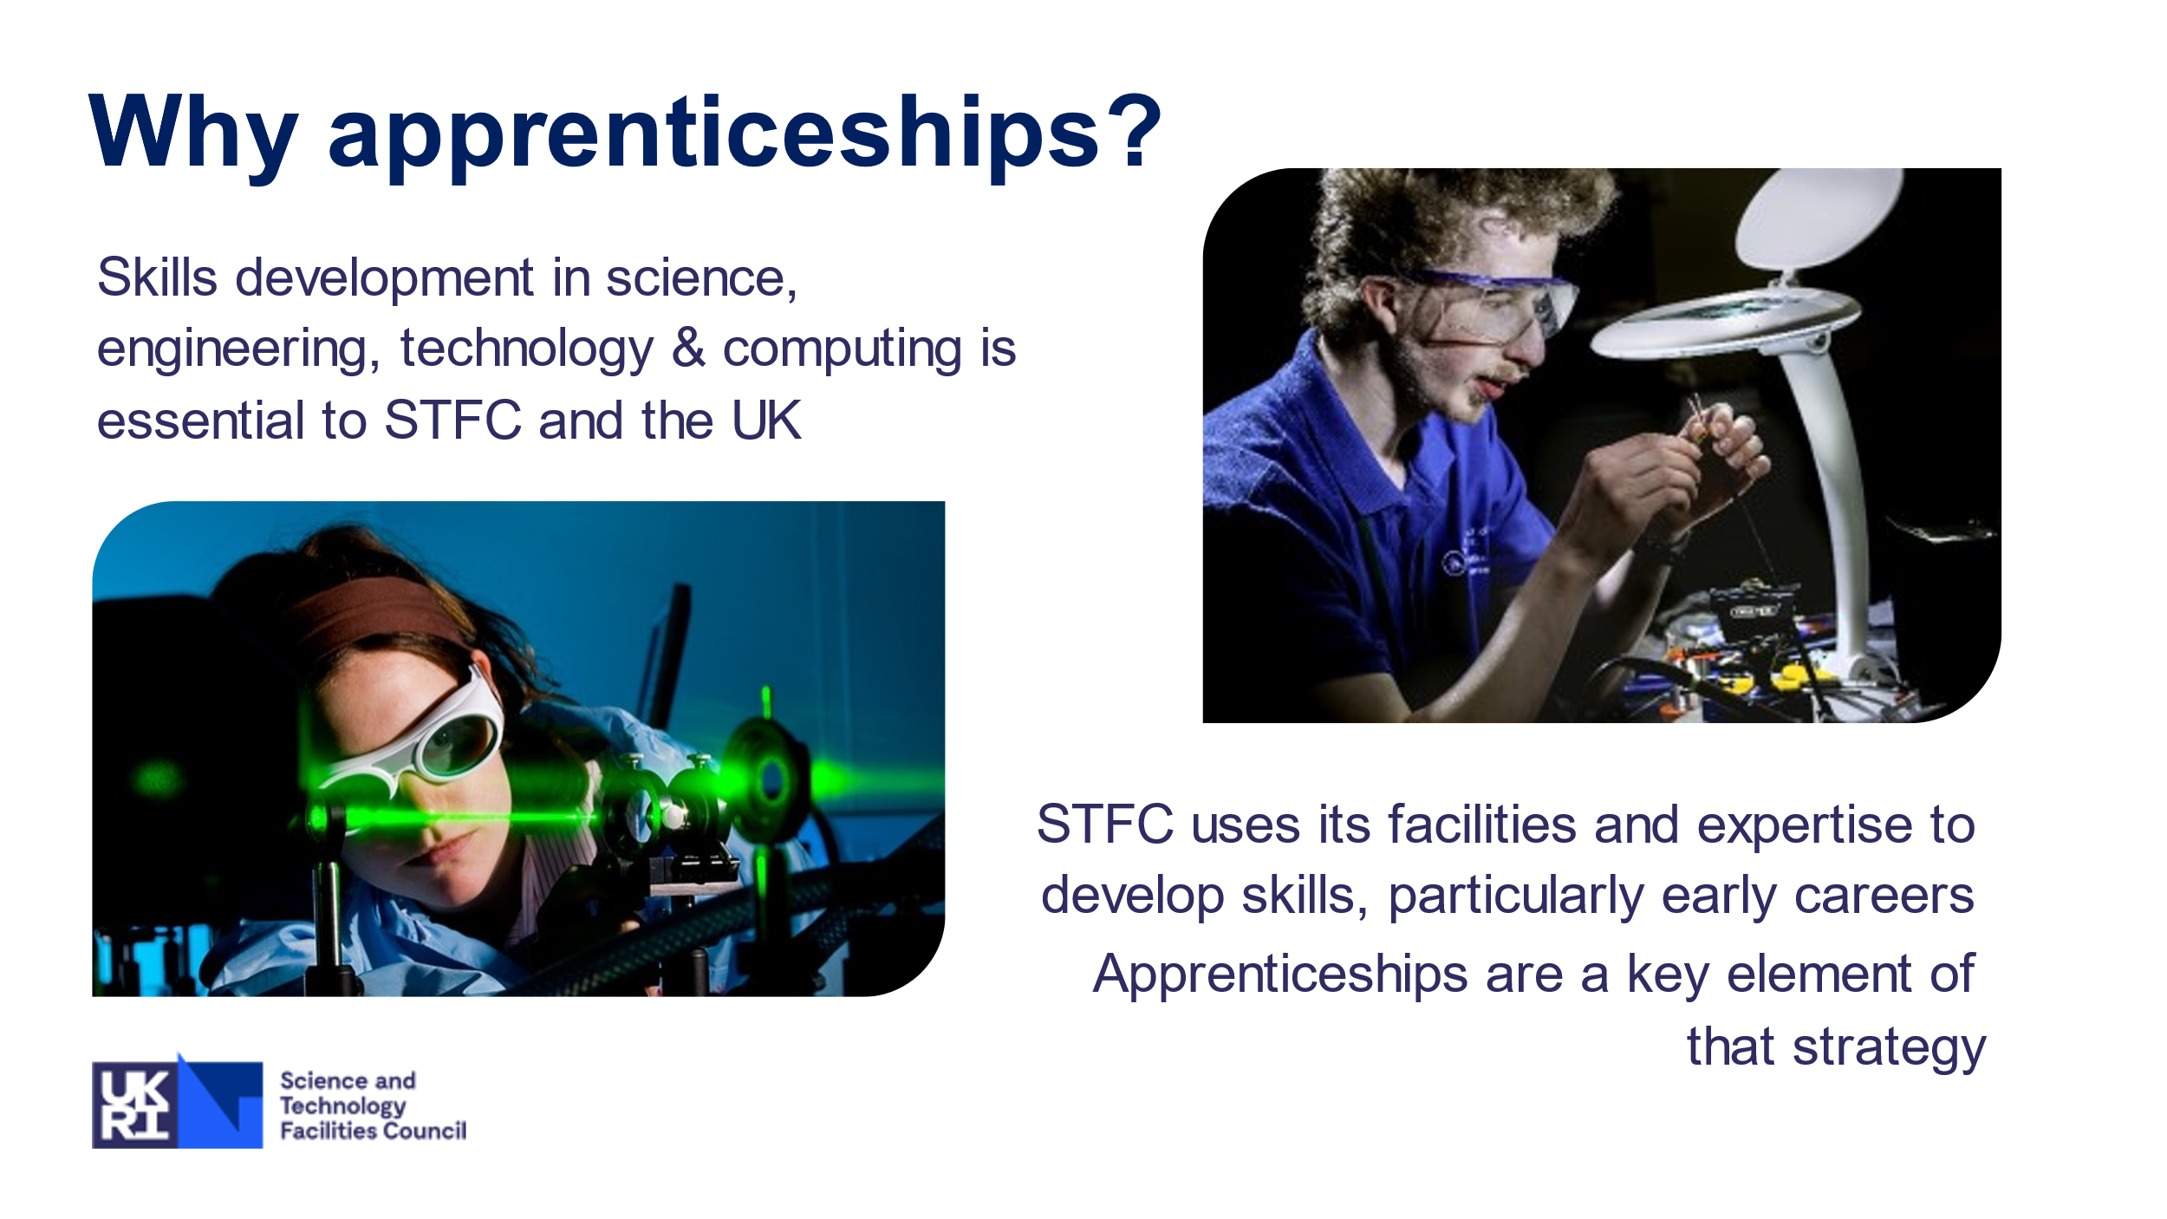

3-stage paragraph model: TEA Topic (Statement)

What point are you trying to make? Explanation (Evidence)

Says who? How does the literature discuss this concept? The ‘Hows’ and ‘Whys’

Application (Comment)

So what? How does this link to your purpose in writing? What is its significance?

https://www.ukri.org/publications/ukri-strategy-2022-to-2027/ukri-strategy-2022-to-2027/

https://ukri.sharepoint.com/sites/thesource-stfc/SitePages/STFC-Strategy-Map-and-Delivery-Plan.aspx?csf=1&web=1&e=uAIAOH

https://stfc365.sharepoint.com

https://ukri.sharepoint.com/sites/thesource/SitePages/Staff-Directory.aspx

https://www.ukri.org/about-us/stfc/how-we-are-governed/

https://www.ukri.org/about-us/who-we-are/ukri-explainers/

https://www.ukri.org/about-us/who-we-are/our-organisation/

structure: that employee tree thing you found (https://ukri.sharepoint.com/sites/thesource/SitePages/Staff-Directory.aspx)

business strategy: to create a very nice well organised research structure in the UK to attract private investors and secure UKs position as world class research country (https://www.ukri.org/publications/ukri-strategy-2022-to-2027/ukri-strategy-2022-to-2027/)

overview of organisation: stuff (<https://www.ukri.org/about-us/who-we-are/our-organisation/>)

Gibbs Model of Reflection

https://youtu.be/5WfnHGq6ztg

